 | 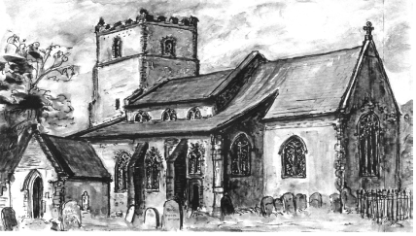
   | 
    FRIENDS OF
    ST. MARY’S CHURCH

 | Coffee Morning
in the Wheel of Fortune garden, Alpington
by kind permission of Naomi and Barry

on Saturday, 16th August, 2025
from 10.30 a.m. to 12 noon

after which the bar will be open if you wish to continue socializing with food and drink

FREE ADMISSION
Mini Spangles Steel Band
Children’s activities
Coffee and cakes, Raffle, Tombola, crafts, gifts and
bric-a-brac, toys and books
Please note - payment will be by cash donation as we have no electronic card facility
For information or to donate items please contact
Mary Fewster (01508 492059)

