A Concert
by the Emergency Services Choir

‘Sacred and Profane’
An eclectic Musical Evening

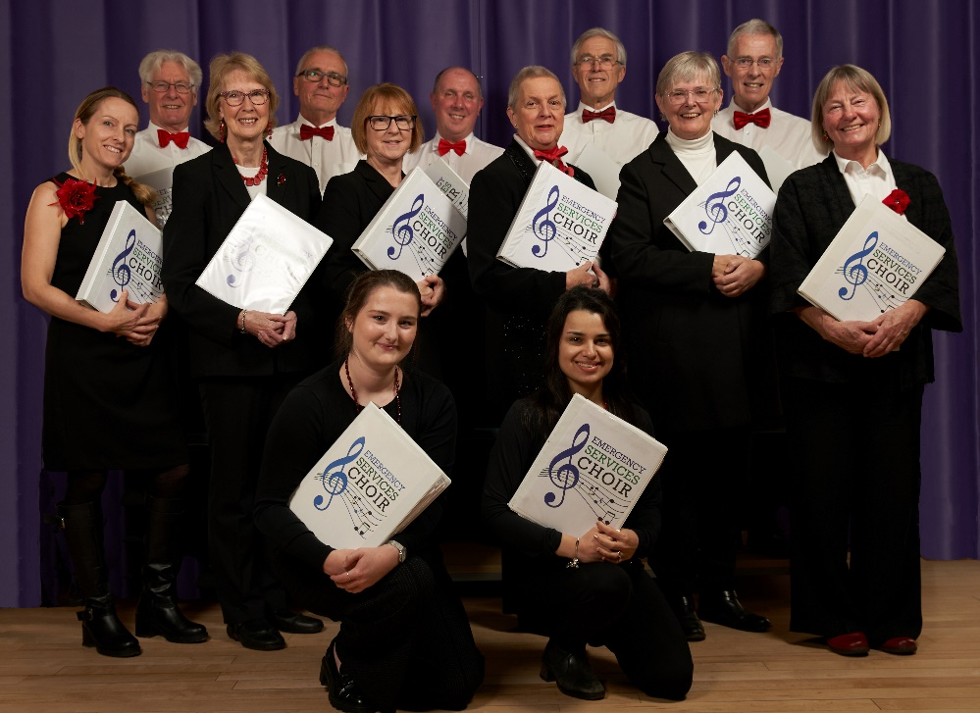

on Friday,11th October, 2024
at 7.00 p.m.
in St. Mary’s Church, Yelverton
Tickets £10 to include refreshments
from Mary Fewster (01508 492059)
 | 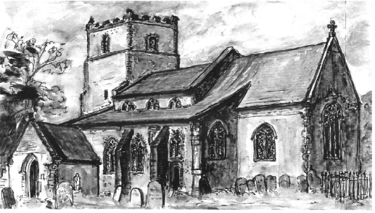
  FRIENDS OF
  ST. MARY’S CHURCH

