Yelverton Pond Project – New Seating Area and Accessible Path

Alpington with Yelverton Parish Council would like to invite interest from local contractors who wish to be considered for this important parish project.

The completed works will create a new seating area and ramped access at the side of the pond which is located on Framingham Earl Road, Yelverton. A full design and specification pack is available and will be issued to contractors with suitable experience, health and safety practices, appropriate insurances and satisfactory references.

In the first instance please contact the Parish Clerk with your credentials and we’ll be in touch soon. clerk.alpington@gmail.com

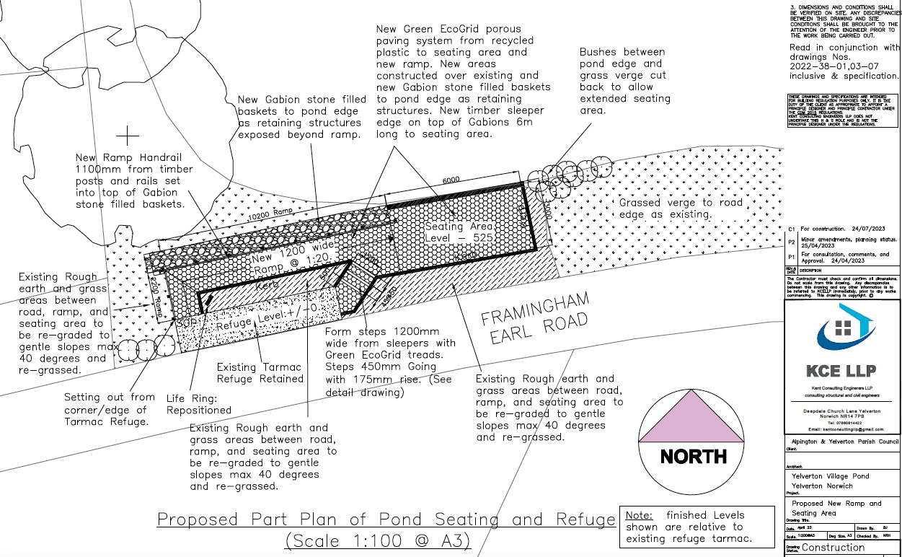

16th August 2023

