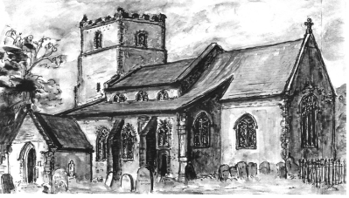 | FRIENDS OF  ST. MARY’S CHURCH

Spring
Quiz Night
(re-arranged Christmas Quiz)
on Saturday 4th March 2023

at Alpington and Yelverton Village Hall

Start time 7.30 p.m.
(Doors open 7.00 p.m.)

£6.00 per person. Tables of up to 6 people
(to book, contact Mary Fewster 01508 492059)

Bring your own drinks and food
Coffee and tea available at the break
Raffle

